Day 0 FMCG

PlaceCom
FMCG Placement Analyzer


Index

Index 2
Glossary 3
Methodology 4
Academics 5
Internships, Work Experience, and Projects 8
Club Positions, Positions of Responsibility, and Extracurriculars 10

Glossary

Term | Meaning
Projects | A project is a focused initiative where students apply their skills to deliver solutions, insights, or innovations within a defined scope and timeline. This includes research projects (including capstone theses), industry projects, etc.
Internships | Short-term work opportunities with organisations that provide practical exposure, skill development, and industry experience.
Positions of Responsibility | Roles where an individual is accountable for tasks, people, or outcomes, demonstrating leadership and organisational ability, and is not necessarily institutional or associated with particular student organisations. Examples - Head boy/girl, Student Council, Student Representatives, etc.
Club Positions | Roles held within student clubs or societies where members manage activities, events, or operations related to the club’s objectives. Examples include President, HoD, Member positions within clubs like Placement Committee, EconSoc, etc.
Extracurriculars | Activities pursued outside academics, such as sports, arts, or theatre, that showcase talent, dedication, and diverse skills.
Work Experience | Professional exposure gained through full-time or part-time employment, reflecting practical application of skills in a workplace setting. This is almost always not coterminous with pursuing education.

Methodology

Sampling: Profile details of 10 students who were placed in Day 0 FMCG companies from the 2022-2023, 2023-2024, and 2024-2025 cycles were taken from Superset. The classification of companies into phases followed Phase-Wise Companies.xlsx. Based on the above data, the following companies and roles were identified:

Company | Role
Hindustan Unilever Limited | Unilever Future Leaders Programme - Management Trainee (Sales & Marketing)
Hindustan Unilever Limited | Management Trainee
Hindustan Unilever Limited | UnileverFutureLeadersProgramme - Management Trainee
Hindustan Unilever Limited | Unilever Future Leaders’ Program (UFLP) - Management Trainee (Sales & Marketing & HR)
Marico Limited | Graduate Trainee under Marico’s Graduate Leadership Program
Pidilite Industries Limited | Management Trainee (Assistant Sales Manager After 1 Year In-Training)
ITC Limited | HR

Method: Data about academics, internships, extracurriculars, and co-curriculars was taken from placed students resumes, extracted from Superset. The collected data was then analysed, visualised, and described to highlight the important aspects of student profiles, along the key variables mentioned above.

Limitations: The study suffers from a limited sample size, and therefore, the conclusions drawn may not be generalisable or representative of your placement experience. Please don’t get demotivated and these are not requirements but typically objective analysis of resumes we have.

Academics
Tenth Percentage  Highest: 99.25%  Lowest: 75.6%  Median: 92.97% | 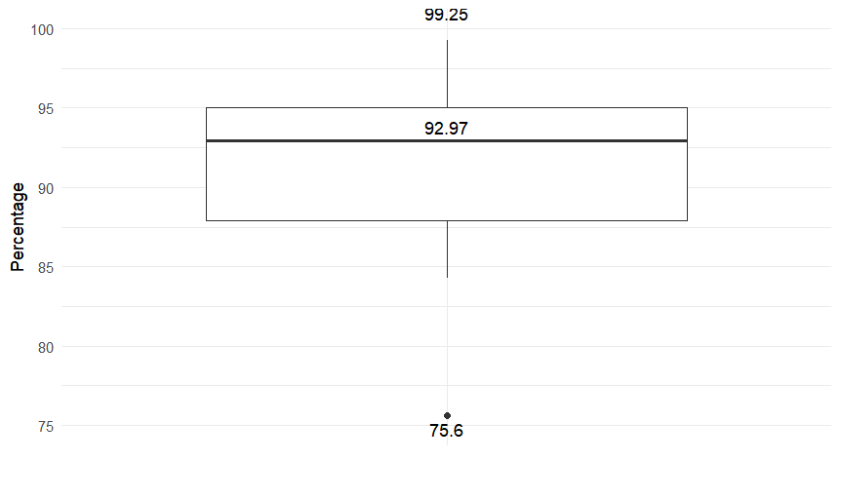
Twelfth Percentage  Highest: 98.4%  Lowest: 86.2%  Median: 93.26% | 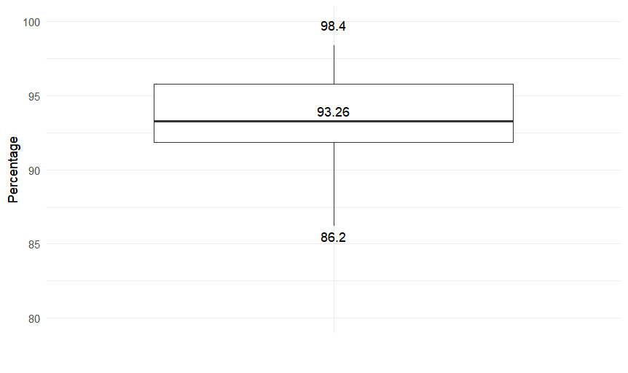
UG GPA  Highest: 3.93  Lowest: 3.13  Median: 3.64 | 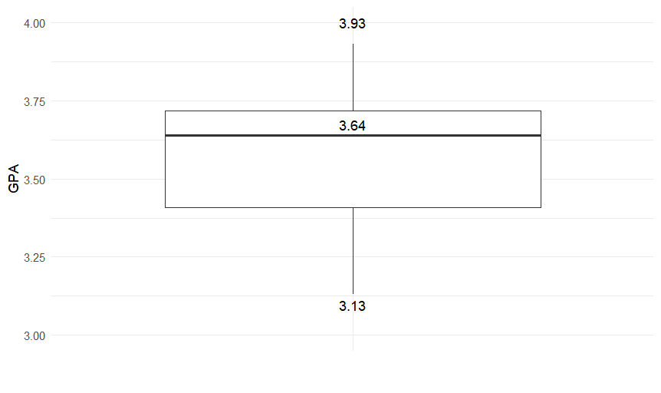

Academic Major Distribution
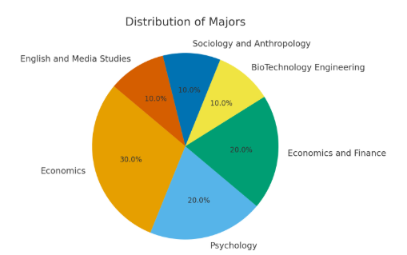

Conclusions
It is apparent that high academic achievement is valued by the coveted FMCG companies. However, the findings do not suggest that companies value consistent high academic performance, as neither Class 12 (β = –0.57, p = 0.51) or Class 10 scores (β = –0.59, p = 0.49) individually, or their interaction (β = 0.006, p = 0.50) strongly predicted UG scores.

For students with lower than median GPAs (<3.64), most students (~80%) compensated with strong extracurricular achievements in areas such as divisional and national level representation in a sport, or significant rewards/achievements in other fields like painting and theatre, which demonstrated qualities like discipline, consistency, and excellence in their chosen field. In addition, students were also served by pursuing relevant internships that aligned with the particular role. Even certifications hold less weight unless they are directly relevant to the position. Such certifications benefit from credibility from a renowned institution like Google or University of California (examples taken from placed student profiles).

It is also likely that FMCG firms are major agnostic based on the diversity of majors represented. Nearly 50% of the students who applied are Economics or Economics & Finance majors, and others belong to STEM (Biotechnology Engineering; 10%), Psychology (20%), Humanities (English & Media Studies and Sociology-Anthropology; 20%). The predominance of Economics majors can also be explained by the fact that most of the applicants are Economics majors.

Internships, Work Experience, and Projects

Internships and projects stand out as the most common and influential factor in securing placements, with students averaging five internships or projects (combined). This strong emphasis on practical exposure reflects FMCG companies’ demand for candidates who can demonstrate industry-relevant skills, adaptability, and real-world problem-solving abilities.

Most students had around four internships, while on the higher end, students had five. On the lower end, few students had around two internships. One of these students had higher educational qualifications and came from a STEM background, making it easier for them to get placed in HUL despite a lower number of internships. On the other hand, the other student with two internships had the highest number of leadership positions, helping them secure a role at Marico Limited.

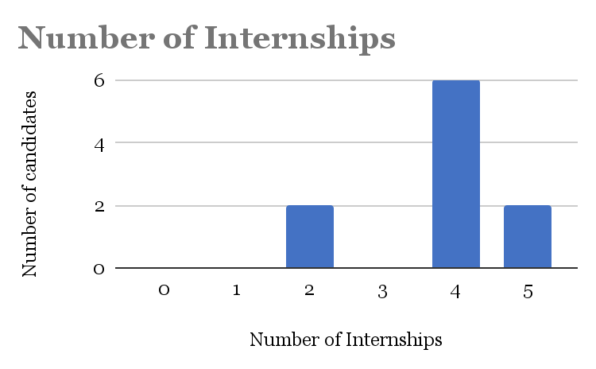

While most of the FMCG companies have offered highly general, management oriented roles, some of them (ITC and HUL) have offered HR and Marketing positions to students. Students have internships across diverse sectors, but it has been observed that students targeting HR or Marketing roles have at least 2 internships in the relevant sector or function. On the other hand, students who got placed in management trainee roles have had internships across wide ranging domains and functions, including finance, research, marketing, etc.

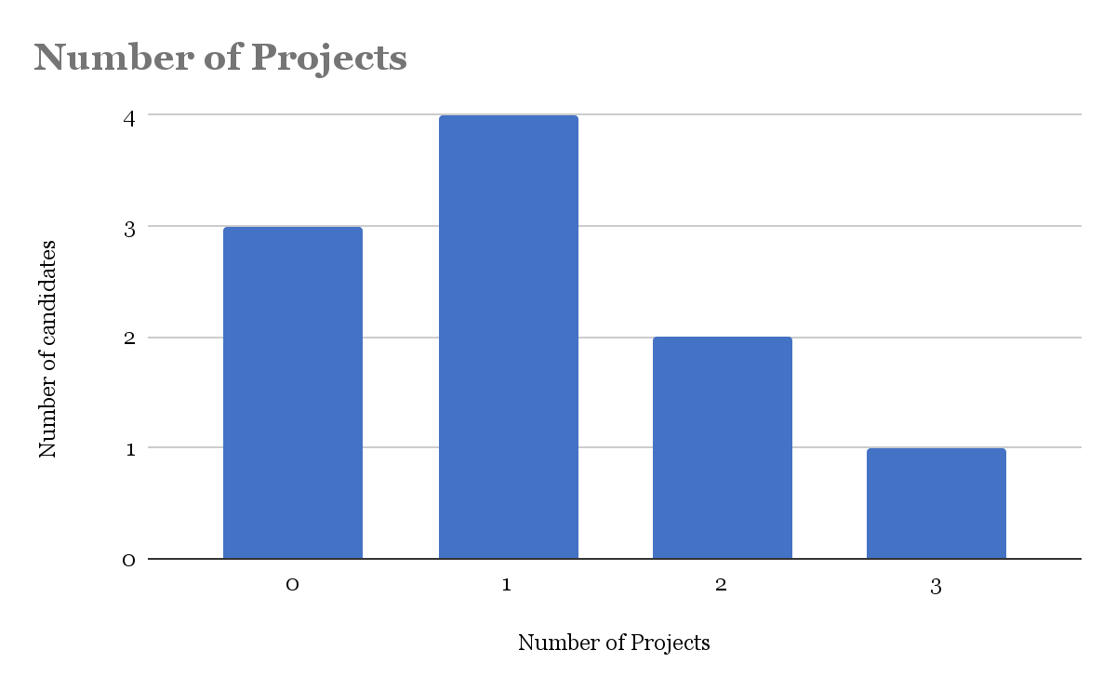

Research and publications: Within projects, only 20-30% of the candidates had research and publications mentioned in their resumes, but they had other components in their resume that overshadowed their research (such as their internships or industry relevant projects) and hence, it is likely that research and publications do not enhance one’s application very significantly.

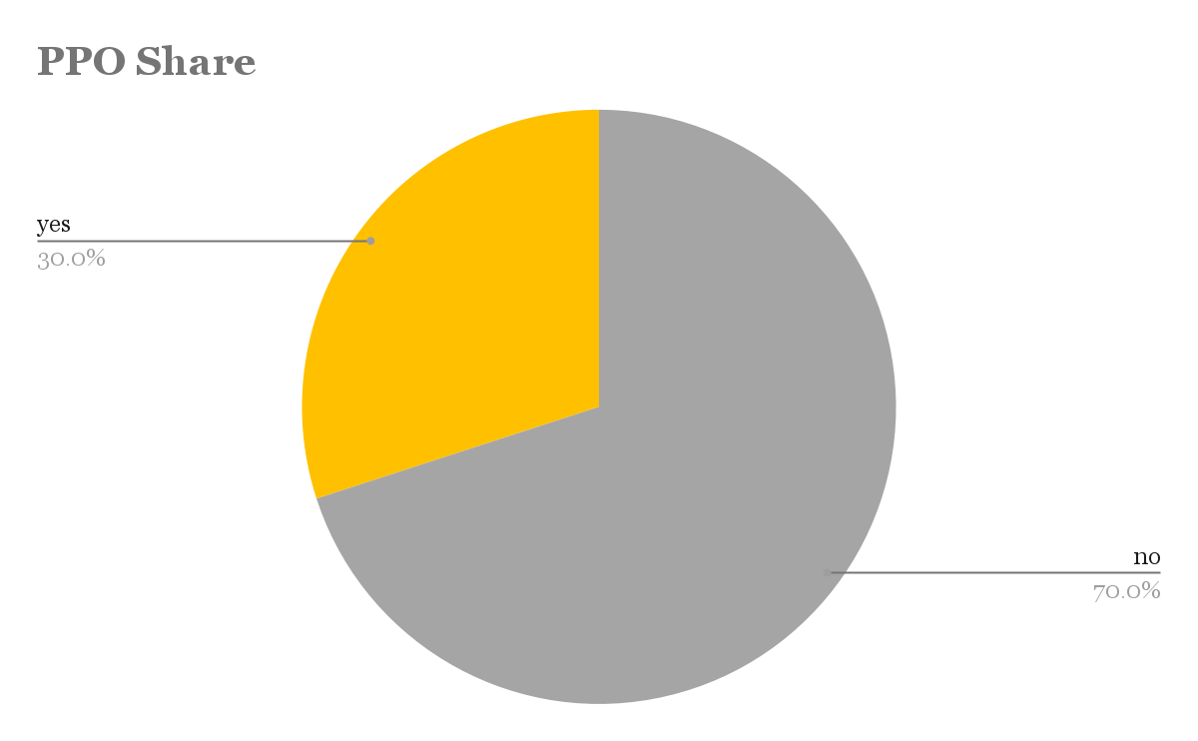

PPO: 70% of the students were hired through direct recruitment, while the other 30% received PPOs. Most students who received PPOs were for management trainee roles, while for HR or Marketing roles, direct, on-campus recruitments were more prominent.

Club Positions, Positions of Responsibility, and Extracurriculars

Leadership positions are less common, but they serve as an important differentiator. Companies like Marico seem to give significant weight to leadership and communication skills, evidenced by the fact that the candidate who got placed in Marico had the highest number of leadership positions (4, compared to 2-3 for others).

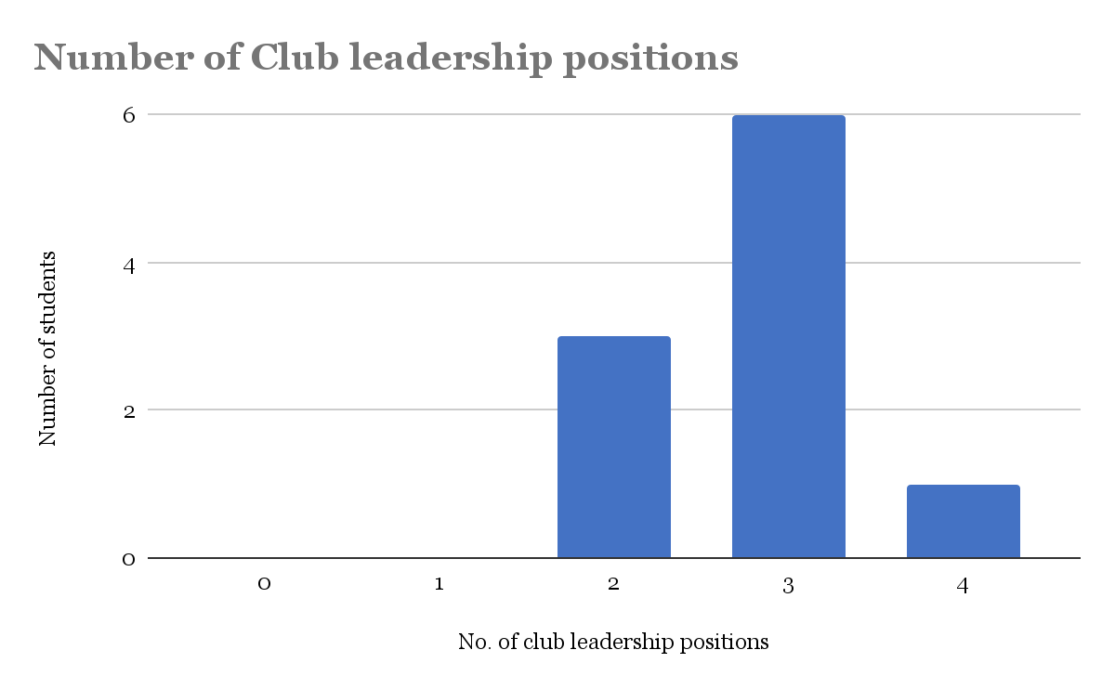

Leadership positions both inside and outside student organisations served as a proof of transferable, soft skills. Most people had 3 positions within student organisations, and 1 position of responsibility. There seems to be no requirement that students had to be a part of clubs or societies that were directly relevant to the roles they were hired for. However, for instance, being the outreach head of a society served as a proof of one’s communication and initiative skills.

A lot of people had significant achievements in fields like sports, art, as well as volunteering experiences. Around 60% had some sort of extracurricular activity outside of the above mentioned categories.

